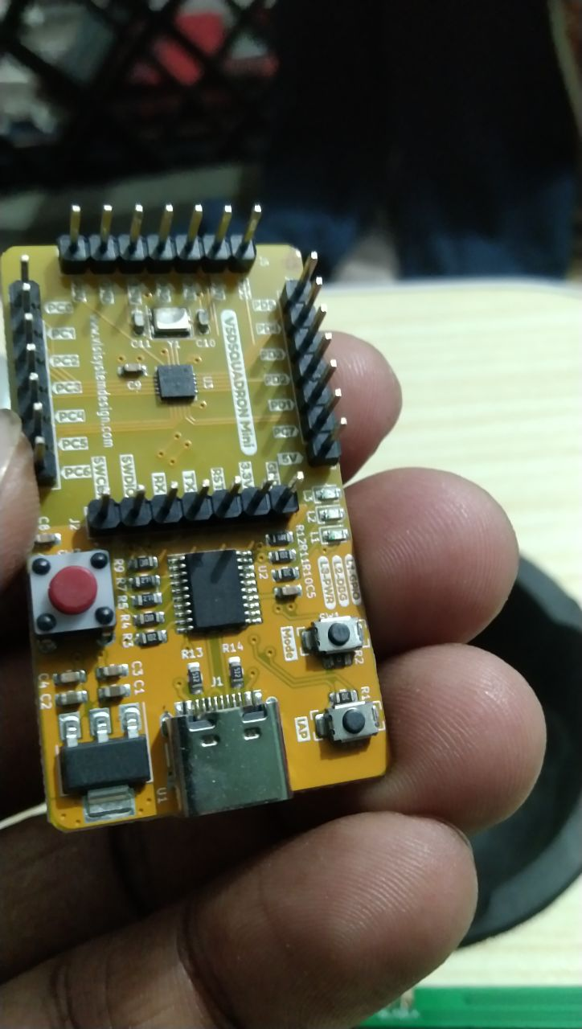
EMBEDDED SYSTEM

RAHUL SHARDHAR BANSOD

Intentionally blank page

About This eBook

The goal of this book is simple: to help readers get familiar with microcontrollers and foster a deeper interest in the embedded world.
Throughout my journey in the embedded industry, I've gained a wealth of knowledge and hands-on experience. In this book, I aim to share everything I've learned, in a way that’s easy for everyone to understand. The language will be kept simple, so that readers from various backgrounds can follow along without difficulty.
I know that reading technical books can sometimes feel slow and tedious—especially when it's easier to look up quick tutorials or videos on platforms like YouTube. I do that too! However, when it comes to problem-solving, videos often fall short. They can leave us confused when we're faced with real-world challenges that require deeper understanding.
This book will tackle that issue by presenting a variety of problems and solutions, designed to deepen your comprehension of core concepts.
I encourage you to not only follow along with the examples but also to practice coding by hand. Working through problems on paper will strengthen your skills and prepare you to solve challenges effectively in real-life scenarios.

INTRODUCTION

The embedded world is where software meets hardware, and the real magic of technology happens behind the scenes. Embedded systems are all around us, powering everyday devices from the simplest gadgets to the most complex industrial machines. These systems are responsible for making things like mobile phones, washing machines, cars, medical devices, and even space exploration equipment work efficiently and autonomously.
At its core, an embedded system is a combination of hardware and software designed to perform a specific task. Unlike general-purpose computers, embedded systems are tailor-made for dedicated applications. They usually consist of a microcontroller or a microprocessor, memory, and input/output peripherals. Embedded systems are highly optimized for the task they are built for, both in terms of performance and power consumption.
The beauty of the embedded world lies in its ability to make things "smart"—embedding intelligence into devices that operate autonomously or with minimal user interaction. From turning on your washing machine with a simple button press to the complex guidance systems in self-driving cars, embedded systems have a profound impact on our daily lives.
In the field of embedded systems, you'll dive into both hardware and software aspects. On the hardware side, you'll learn about microcontrollers, sensors, actuators, and communication protocols. On the software side, you'll work with low-level programming languages like C , C++, Assembly, RUST and gain an understanding of real-time operating systems (RTOS) that manage how embedded devices function in real-time.
This field requires a unique blend of skills. You'll need to think like a software engineer and a hardware designer at the same time. The challenge is to write efficient, reliable code that interacts directly with hardware while meeting strict constraints like power consumption, processing speed, and memory usage.
One of the key advantages of learning embedded systems is that it opens doors to industries like consumer electronics, automotive, aerospace, medical devices, and IoT (Internet of Things). As more devices get connected to the internet and become "smart," the demand for embedded systems engineers continues to grow.
In this book, you will explore the key concepts, tools, and challenges involved in designing embedded systems. Whether you’re new to the embedded world or looking to deepen your knowledge, this guide will provide practical insights, real-world examples, and problem-solving techniques to help you succeed.
Welcome to the embedded world—a place where hardware and software come together to make everyday things extraordinary.

